### Part g - Using Vertex ML Metadata with Pipelines

In this part, we used vertex AI to -

* Use the Kubeflow Pipelines SDK to build an ML pipeline that creates a dataset in Vertex AI, and trains and deploys a custom Scikit-learn model on that dataset
* Write custom pipeline components that generate artifacts and metadata
* Compare Vertex Pipelines runs, both in the Cloud console and programmatically
* Trace the lineage for pipeline-generated artifacts
* Query your pipeline run metadata

1. Setting up cloud session, enabling APIs and giving necessary permissions to the computer services to the created bucket

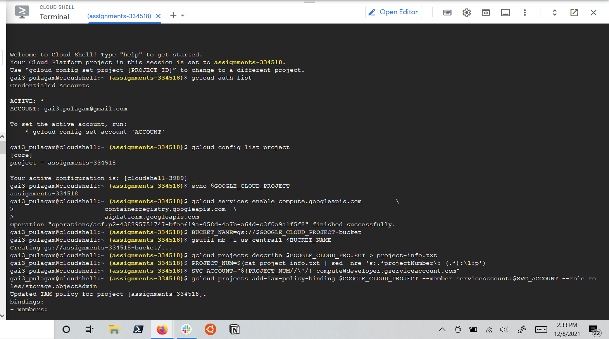

1. Creating notebook instance on vertex AI

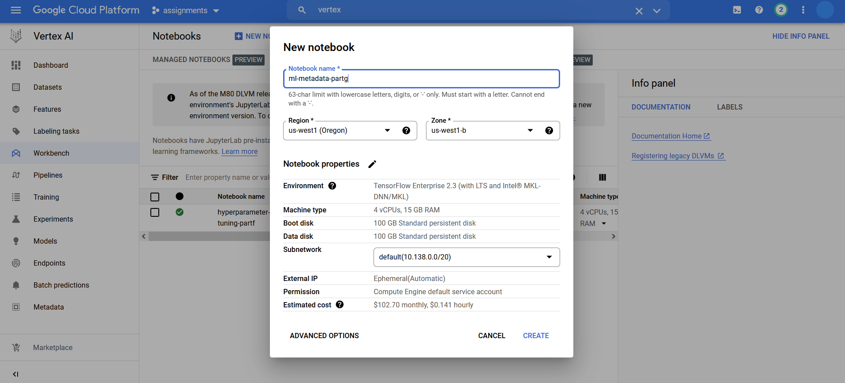

1. Specifying components to create pipeline yaml files in a notebook, and running pipelines

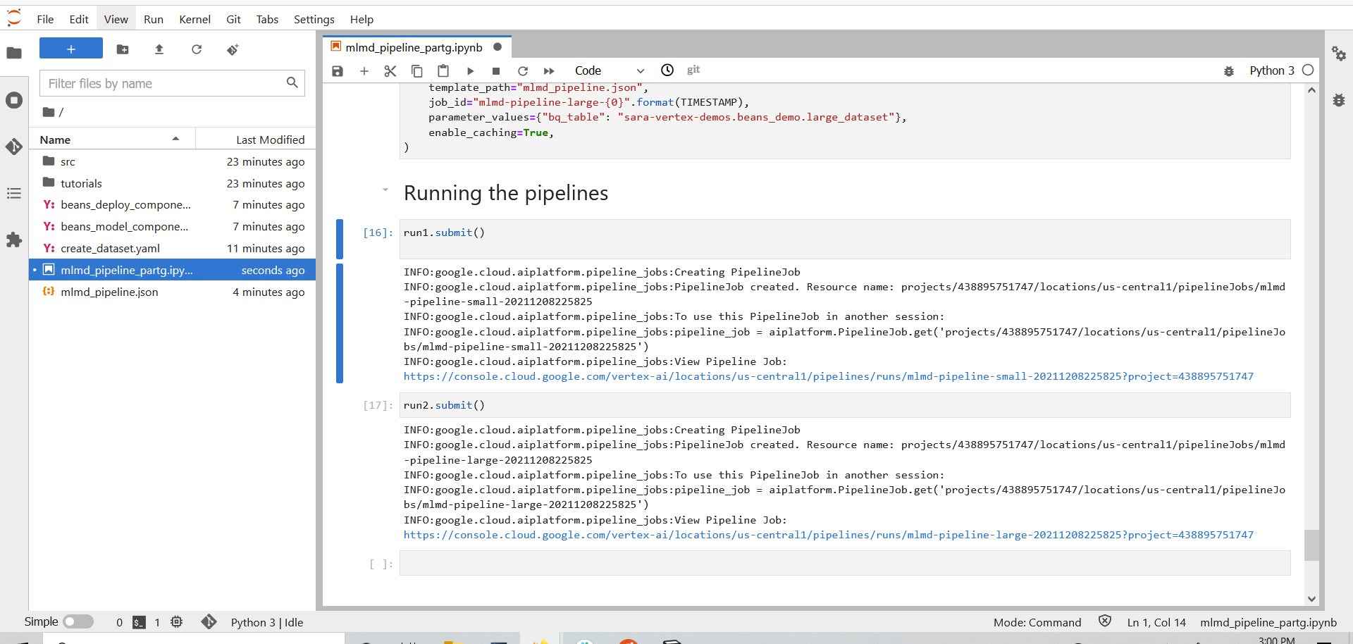

1. The pipeline running on the vertex UI

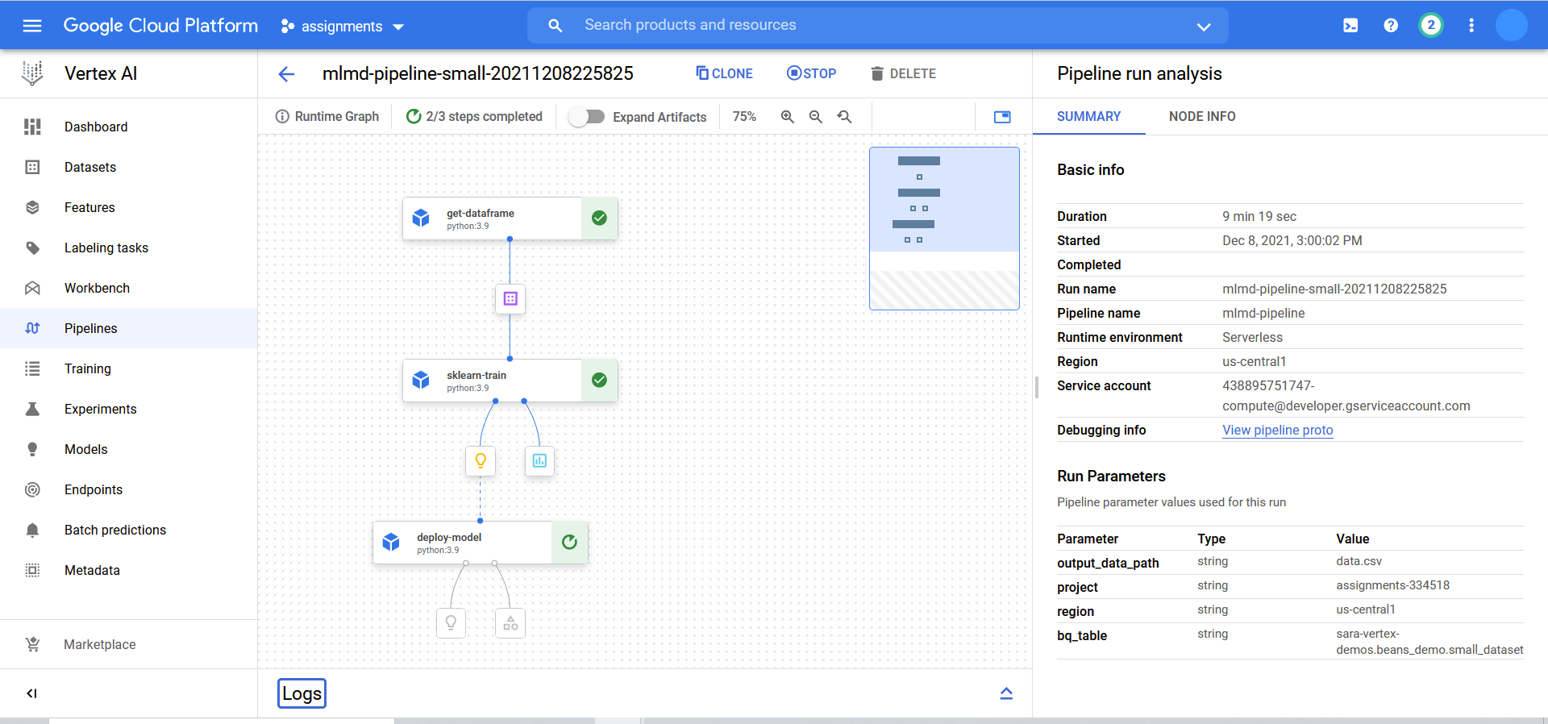

1. Comparing pipelines and more details regarding the pipelines

Pipeline completed, expanded artifacts

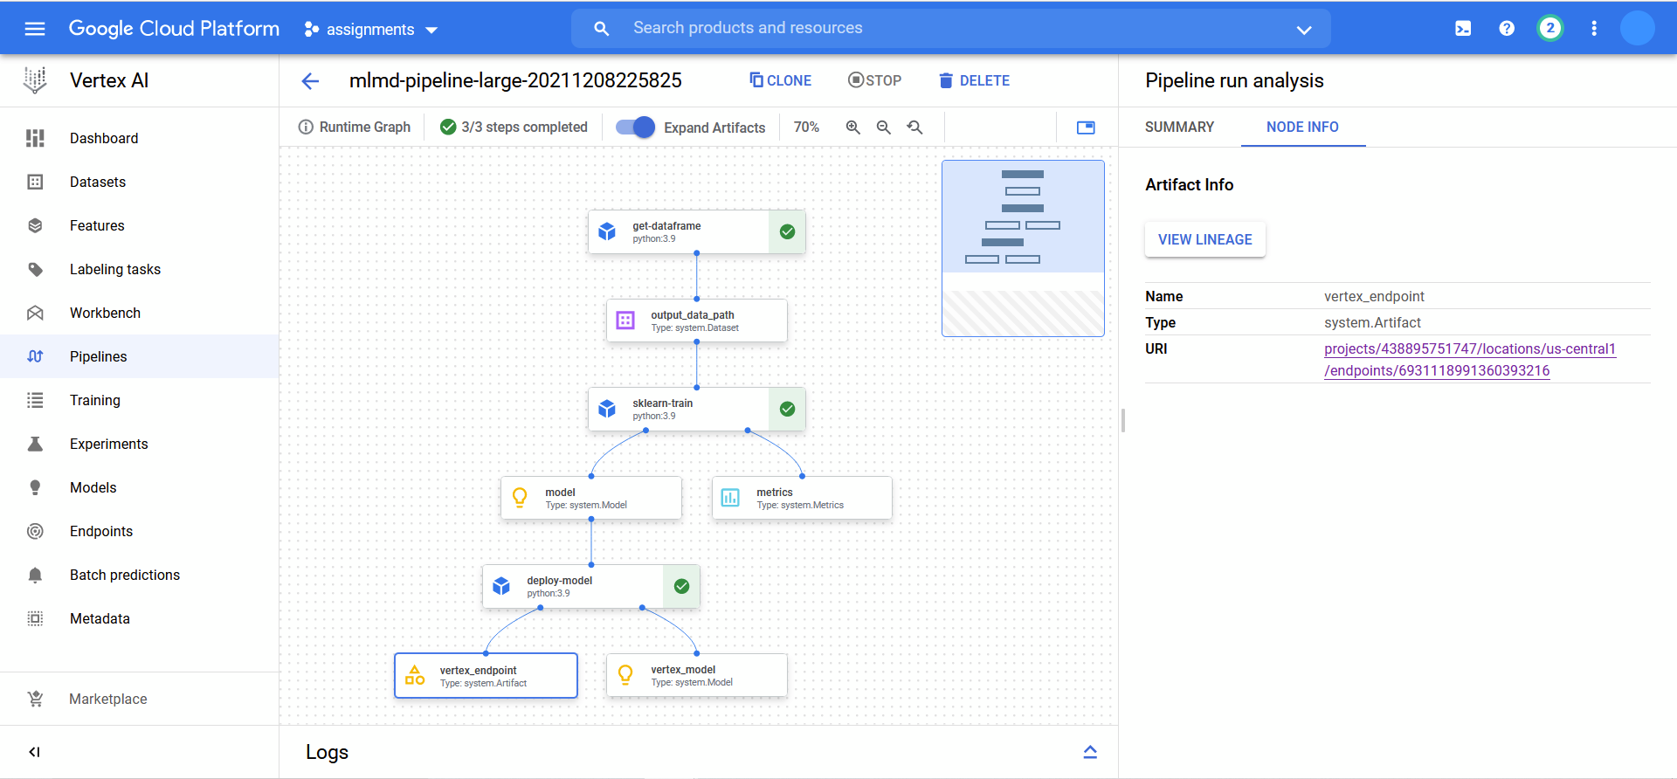

Trained models in the pipeline

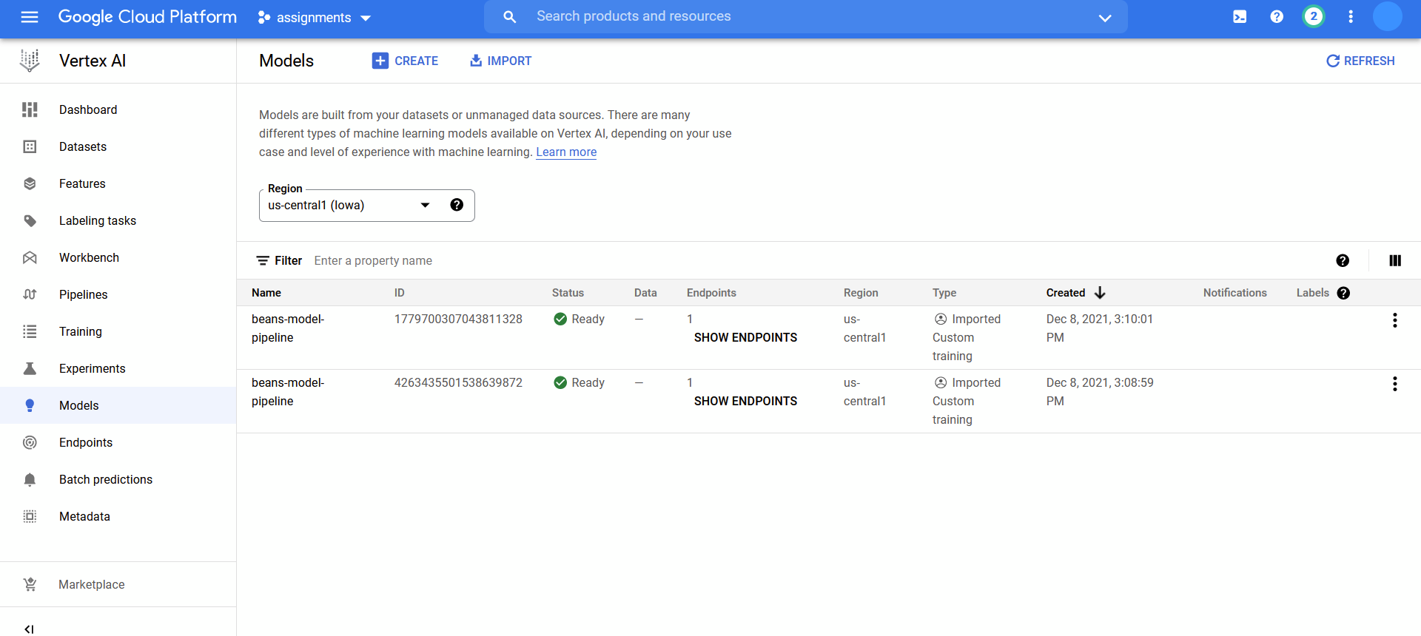

Endpoint created in the pipeline

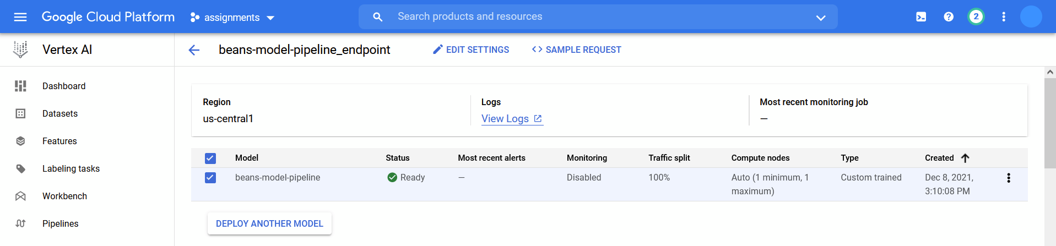

Comparing the small pipeline and large pipeline using the vertex UI

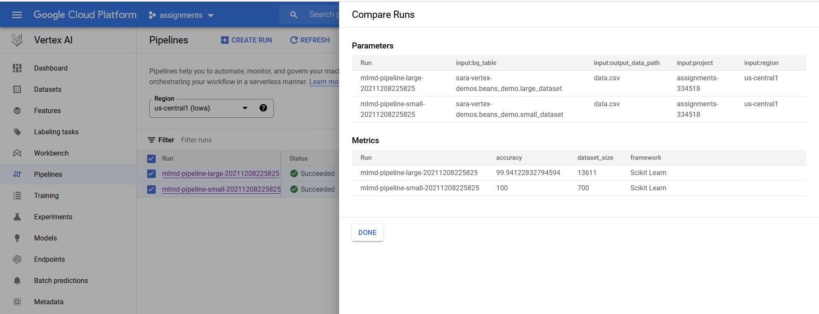

1. Querying model artifacts and displaying the details in an organized dataframe

